Expected Level
Reception (October) | Recognise the sounds:  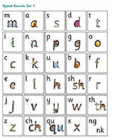  m,a,s,d,t,I,n,p,g,o,c,k,u,b,f,e,l,h,sh  Can orally blend e.g. If you say the sounds ‘m-a-t’ the children can hear the sounds and say ‘mat’.  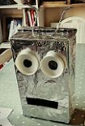  Games to support oral blending at home:  - Talk like a robot and ask the children to find things e.g. “Can you find the c-u-p”.  - Make metal mike – place pictures or real objects around metal mike, ask the children to feed him certain objects e.g. the s-o-ck-s.  - Play Simon Says but instead of saying can you touch your ‘head’ say can you touch your ‘h-ea-d’.
Reception (December) | - Recognise all set 1 sounds as shown in the chart.  - ‘Blend’ (read) CVC words (3 letter words) containing set 1 sounds.  E.g. bin, can, cot, mat, sat.
Reception (February) 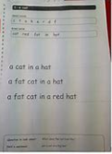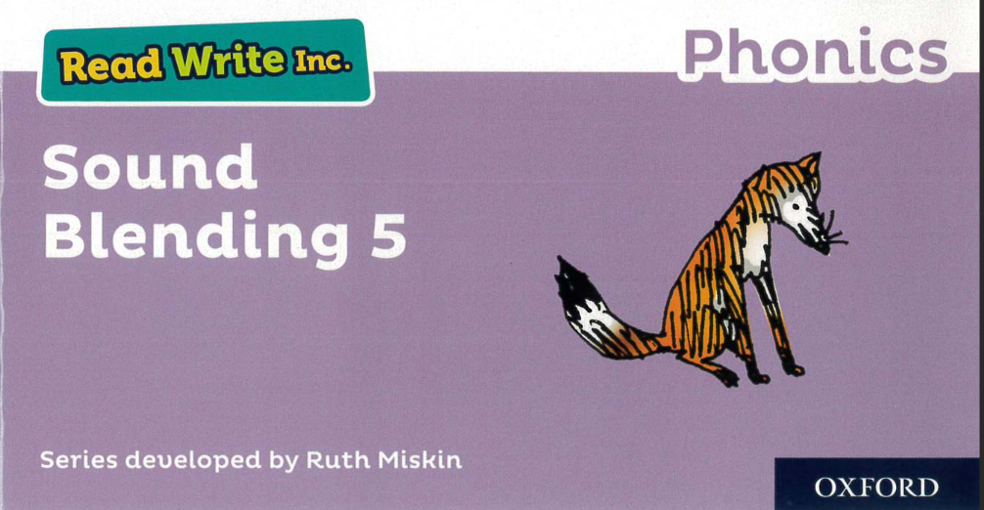 | - Read all set 1 sounds speedily when they are shown the letter sound.  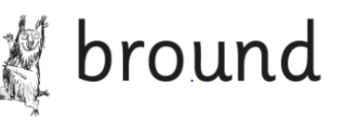  - Read 3 letter words (CVC words) by Fred-talking (sounding out) e.g. c-a-t ‘cat’.  - Read 3 letter nonsense words (alien words) by Fred talking  *Alien/ nonsense words are a mixture of letters that include a sound that the children have been taught (see example above). Reading alien words is a way to check that the children can recognise the sounds that they have been taught and if they can blend them together to make a word. The word will always have an alien symbol next to the word to remind the children that it is a nonsense word.
Reception (April)  Red Ditty Books  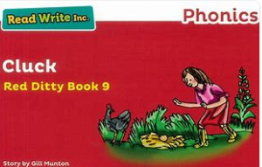 | - Read words with 4 or 5 sounds e.g. pram, stamp.  - Read nonsense (alien words) containing 3 or 4 sounds by saying each letter then reading the word.
Reception (May-July)  Green Books  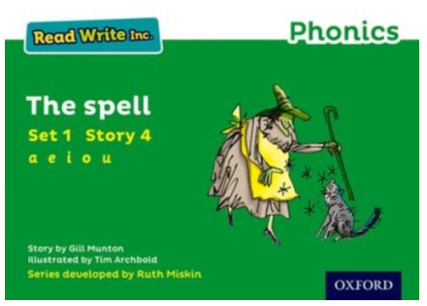 | - Read words containing 4 or 5 sounds (from the set 1 sounds)  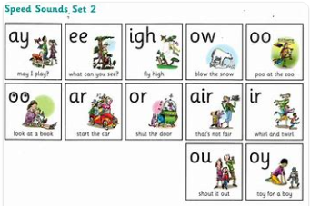  - Speedily read the first 6 sounds in set 2 (ay ee igh ow oo oo)  - Speedily read these sounds in words.  - Notice these sounds (ay ee igh ow oo oo) in nonsense (alien words) and sound out the word, noticing that it is a nonsense word.
Year 1 (October)  Purple Books  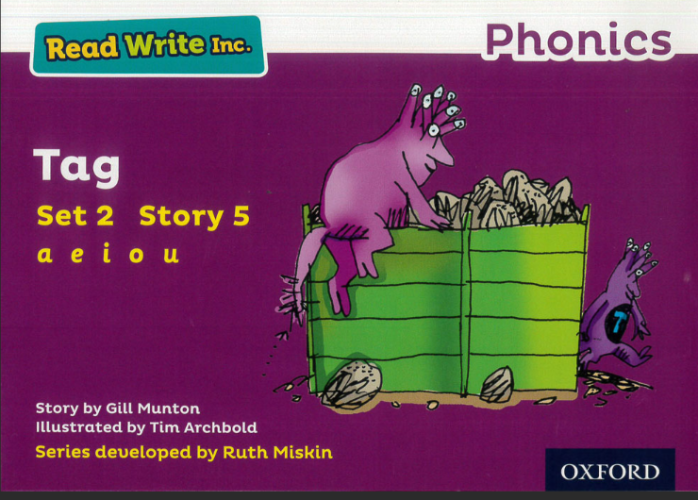 | - Read words containing 4 or 5 sounds (from the set 1 sounds)  - Speedily read the first 6 sounds in set 2 (ay ee igh ow oo oo)  - Speedily read these sounds in words.  - Notice these sounds (ay ee igh ow oo oo) in nonsense (alien words)  and sound out the word, noticing that it is a nonsense word.
Year 1 (December)  Pink Books  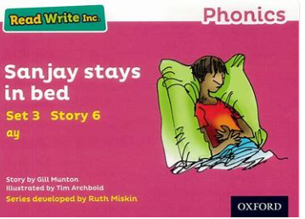 | - Read the last 6 sounds in set 2 (ar or air ir ou oy) speedily  - Read these sounds in words by ‘Fred-talking’ (sounding out) in both real and nonsense (alien) words.  - Read ( ay ee igh ow oo oo) in green words speedily (without having to sound out each letter- the children can read the words in their head).
Year 1 (February)  Orange Books  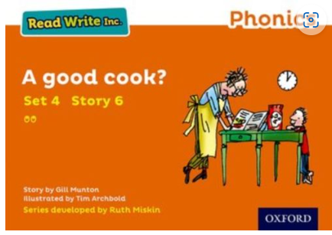 | - Read all set 2 sounds in words speedily.  - Read set 2 sounds in nonsense words by ‘Fred-talking’ (sounding out).
Year 1 (April)  Yellow Books  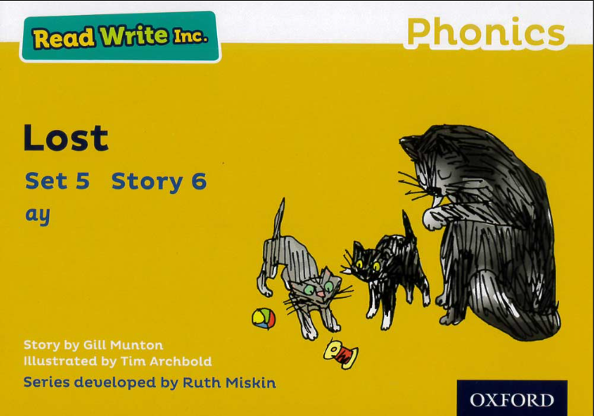 | - Read the first 6 set 3 sounds (a-e ea i-e o-e u-e oi) as shown in the chart (speedily).  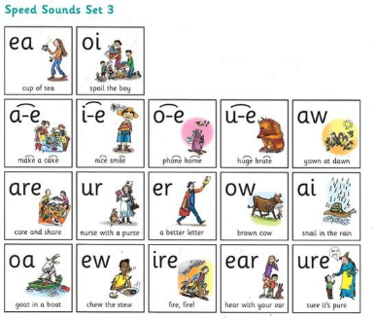  - Read these sounds in real and nonsense words using Fred talk.  - Read a passage at 60-70 words per minute attempting intonation (change in voice/expression when reading).
Year 1 (July)  Blue Books  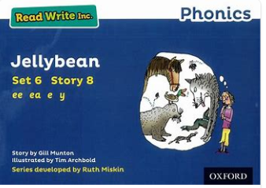 | - Read all set 3 sounds speedily.  - Read set 3 sounds in nonsense words by Fred talking. Read a passage at 70-80 words per minute attempting intonation.
Year 2 (Dec)  Grey Books  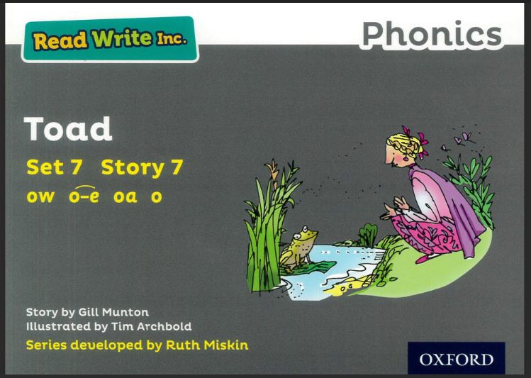 | - Read all set 3 sounds in nonsense words (alien words) using Fred talk.  - Read multi-syllabic words speedily. E.g. con-ver-sa-tion- conversation.  - Read a passage at 80-90 words per min with intonation that shows comprehension.

