__
Carr Mill
Primary School
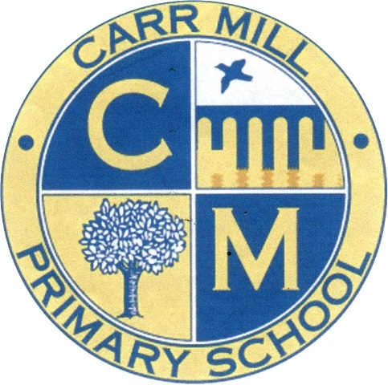

School Uniform Policy

June 2022
School Uniform policy Carr Mill Primary
2009

At Carr Mill Primary, we firmly believe in the value of school uniform in order to maintain and reinforce the school’s culture of high expectations and academic achievement. It is expected that all children will dress according to the policy and will wear the correct school uniform, including footwear, every day. This fosters a feeling of belonging to the Carr Mill Community, and helps children feel equal to each other. It is how we can identify ourselves as part of the school community and it promotes a strong, cohesive school identity which supports high standards and expectations in all areas of school life. It promotes harmony between different groups represented in school, and enhances security.

Smartness and high standards of appearance are expected at all times.

Why do we have a required school uniform?

- Uniforms unite the school. Children and parents make a commitment that when they put on their Carr Mill Uniform they will abide by the rules of the community.

- Uniforms reduce distractions. We are focused on achieving success and allowing all children to achieve their personal best. When children are allowed to wear their own clothing, there is a potential to talk about fashions and styles rather than learning.

- Uniforms make all the children equal. Regardless of home income, the children all come to school looking the same way. No one has to feel bad about the clothes they do or don’t have.

- Uniforms look professional. Children look neat and ready to learn. It is part of the routine.

How is the policy monitored and reviewed?
The governing body supports the teacher in implementing the school uniform and appearance policy. It considers all representations from parents regarding the policy and liaises with the headteacher to ensure the policy is implemented fairly and with sensitivity. It is the governor’s responsibility to ensure that the uniform meets all regulations concerning equal opportunities. Governors ensure that the school uniform enables children to dress sensibly, in clothing that is hardwearing and practical and is safe.

What is the Carr Mill Uniform?

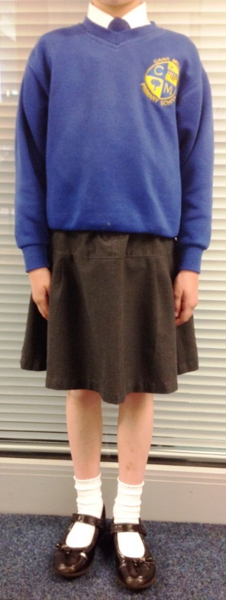
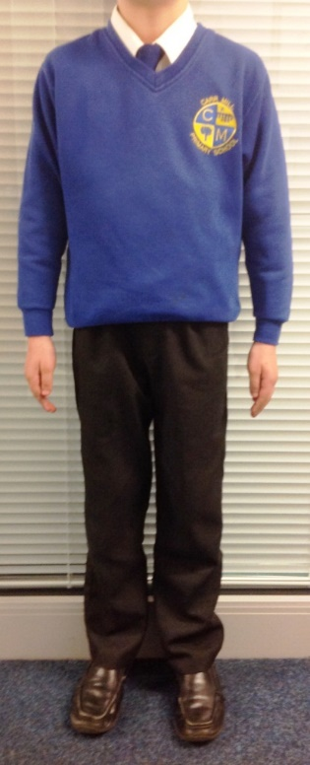
White Shirt
Blue School Tie*
(see School Ties note)

Royal Blue V-neck Jumper
(You may wish to purchase one with the with school logo from school shop)

Grey Trousers / Skirt

Plain Grey/White Socks

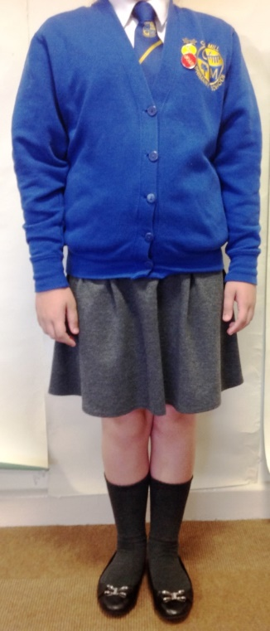
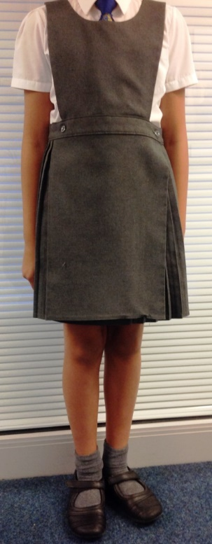
Royal blue V Neck Cardigan
(You may wish to purchase one with the with school logo from school shop)

Grey Pinafore

Black Shoes

- * School Ties: All children should wear the blue school tie throughout the school year from September (EYFS/KS1 elasticated, KS2 clip on). Children who have been awarded a Golden Tie should revert back to their blue tie at the start of the next school year. A free Golden Tie will be provided to children who are elected onto a School committee in September.

- Footwear: Must be sensible black shoes. Trainers are not allowed.

- Shirts: Standard white shirts for girls and boys (no scalloped collars).

- Socks/Tights: Socks should be grey or white (no stripes or spots). Tights should be plain grey,
- Long hair: Should be tied up at all times with minimal, small hair accessories (either in black or school colours)

- Jewellery/Decoration: No jewellery is allowed in school. This includes earrings and studs (these must be removed - plasters will not be allowed to cover them up). No tattoos, nail varnish or make-up is to be worn in school.

- Summer Dresses: Small gingham blue checked Summer Dresses with plain white socks can be worn during warmer weather.
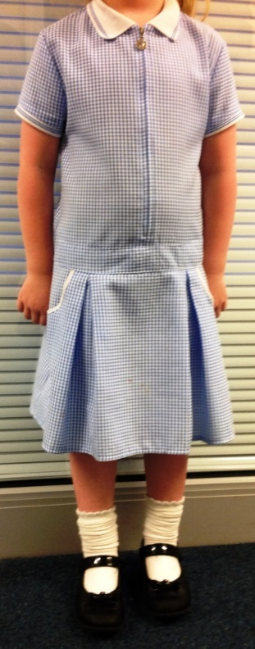
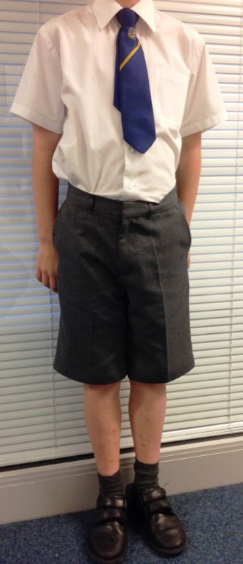

Small gingham blue checked summer dress

Grey Shorts

P.E. Kit (Indoor)
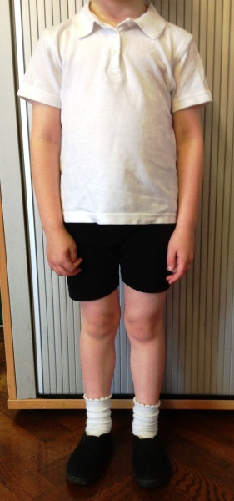
Plain white polo top / T shirt

Black/Navy shorts Shorts

Black Indoor Pumps.
Note: trainers will not be allowed indoors

P.E. Kit (outdoor)
For outdoor P.E. children should still have their Indoor Kit available. They can then wear Black or Navy tracksuit / jogging bottoms and outdoor trainers to suit. Branded or football clothing of any type is not permitted for P.E. lessons.
Hoodies are not allowed (this is to prevent possible accidents when taking part in physical activities).
IMPORTANT: P.E. is a compulsory part of the curriculum, and it is essential that children have their P.E. kit in school in order to take part in these lessons.
Jewellery (including earrings/studs), Decoration and other items
Earrings/Studs
No jewellery is allowed in school. This includes earrings and studs. We understand that some children may have their ears pierced during the school holidays. Please ensure that if they do, ears are pierced at the start of the holidays as rings/studs must be removed for school in September. Please note that plasters will not be allowed to cover earrings/studs. No tattoos, nail varnish or make-up are to be worn in school.
Hair
Hair styles should be kept simple and appropriate for school. ‘Razored’ or ‘Tram Line’ styles are not appropriate.

Bags
Due to limitations of storage space, large bags should not be brought into school. Children are strongly encouraged to have a reading bag. Indoor P.E. kits can be kept in school over a half term and should be brought in a small bag (ideally a drawstring type bag) with the child’s name inside.
Naming clothing and property
It is vital that all clothing and property is clearly marked and labelled so that it can be easily traced and returned. Carr Mill Primary school cannot accept responsibility for loss or damage to child’s property/ valuables.
Lost Property
All mislaid items will be passed to the lost property box in the Key-stage Managers rooms. (Mr D Hunter – EYFS Manager/ Miss S Hampton- KS1 Manager/ Miss G MacKenzie- KS2 Manager). We will endeavour to return all named property.

What happens if there is non-compliance with the uniform policy?
Carr Mill Primary school will always be considerate and discrete in trying to establish why a child is not wearing the correct uniform. In line with all our work at Carr Mill- we encourage discussion with the school, whether this be with the teacher or pastoral team, at the earliest opportunity if you are having any difficulties. Parents should be assured that we will do what we can to help. However, it is vital that all children adhere to the policy.
If required, school will try and support families who may need it in accessing some preloved uniform. Please contact us if you think you need this and we will look to supporting you with this.
In instances where a child is found to be in non-compliance- a discreet word/ phone call or school spider message will be made in the first instance to advise and discuss with the parent. If the matter is not rectified, then a letter will then be sent home by the class teacher (Appendix 1) to remind parents.
Persistent non-compliance
In the event that, after the previous steps have been taken, there is continued persistent non-compliance of the policy, the headteacher will send a formal letter out to the parents. (Appendix 2)
In addition, failure to comply with the school’s uniform policy will prevent a child from representing the school at events or be considered for roles of responsibility in school.
In the case of jewellery (earrings/studs) your child will not be allowed to access outdoor provision at breaks/lunchtimes or fully take part in P.E. (for safety reasons). Please note that PE lessons are part of the National Curriculum and all children are expected to take part.
Open defiance to policy
If the matter still does not rectify itself the Headteacher will contact the parent directly.
In extreme cases where there is a clear breach of policy and open defiance of the school uniform and appearance policy, and where all other avenues have been exhausted, the school may consider exclusion. Carr Mill Primary school will try and avoid this wherever possible by working with the parents and carers but this may be an outcome.

Appendix 1- Letter to parents in first instance of not following uniform policy

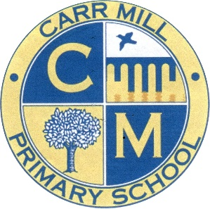
Headteacher: Mr A Maley
Carr Mill Primary School
Kentmere Avenue
St Helens, WA11 7PQ
01744 678223
www.carrmillprimary.co.uk

Dear Parent/Carer,

Our policy states:

“At Carr Mill Primary, we firmly believe in the value of school uniform and ask for your support in maintaining the school’s high standards of appearance. This fosters a feeling of belonging to the Carr Mill Community, and helps children feel equal to each other.”

(Put the part of the policy in here that the child is in breach of)

A letter reminding you of the school policy was sent out prior to the school holidays in July. You have also been reminded of the policy and the expectations on several occasions, by (INSERT how you have contacted them)

Please be aware that failure to follow the school’s uniform policy could prevent your child from representing the school at events or be considered for roles of responsibility in school.

In addition, in the case of jewellery (earrings/studs) your child will not be allowed to access outdoor provision at breaks/lunchtimes or fully take part in P.E. (for safety reasons). This lesson is part of the National Curriculum and all children are expected to take part in it.

Please rectify the matter as soon as possible and should you wish to discuss any details in relation to this or any difficulties you may have regarding this please contact the class teacher, school office or pastoral team at your earliest convenience.

Thank you for your support in this matter.

(INSERT Name) & (INSERT KS Manager name)

Appendix 2 Persistent non-compliance- headteacher letter

Headteacher: Mr A Maley
Carr Mill Primary School
Kentmere Avenue
St Helens, WA11 7PQ

01744 678223
www.carrmillprimary.co.uk
Dear Parent/Carer,

We are aware that your child is wearing/does not have .

Our policy states:

“At Carr Mill Primary, we firmly believe in the value of school uniform and ask for your support in maintaining the school’s high standards of appearance. This fosters a feeling of belonging to the Carr Mill Community, and helps children feel equal to each other.”

(Put the part of the policy in here that the child is in breach of)

A letter reminding you of the school policy was sent out prior to the school holidays, along with a suggestion that any piercings be done at the start of the holidays to give the ears time to heal. You have also been reminded of the policy and the expectations (INSERT how you have contacted them).

Furthermore, a letter has been sent to you to remind you of the requirements of the school policy, however, the matter has still not been rectified.

Please be aware that failure to follow the school’s uniform policy will now prevent your child from representing the school at events or be considered for roles of responsibility in school.

In addition, in the case of jewellery (earrings/studs) your child will not be allowed to access outdoor provision at breaks/lunchtimes or fully take part in P.E. (for safety reasons). This lesson is part of the National Curriculum and all children are expected to take part in it.

We would therefore expect that from now on your child is dressed appropriately every school day and any earrings/studs are immediately removed.

Thank you for your support in this matter.

Mr A Maley
(Head Teacher)

