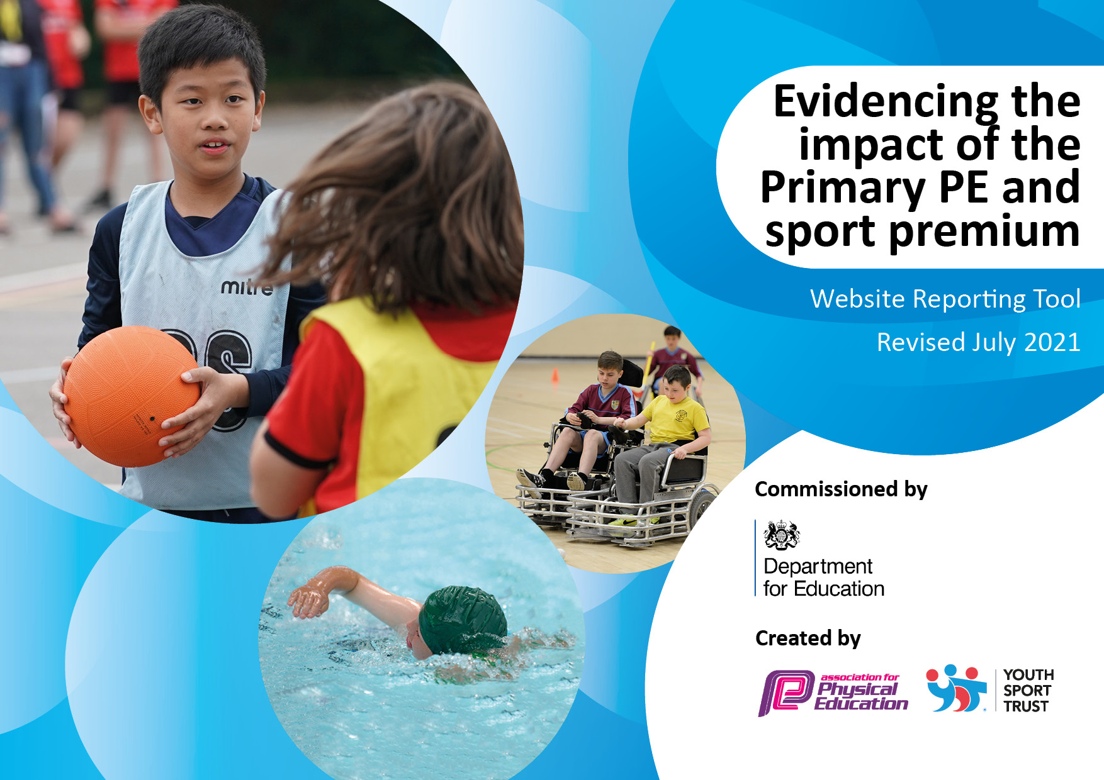
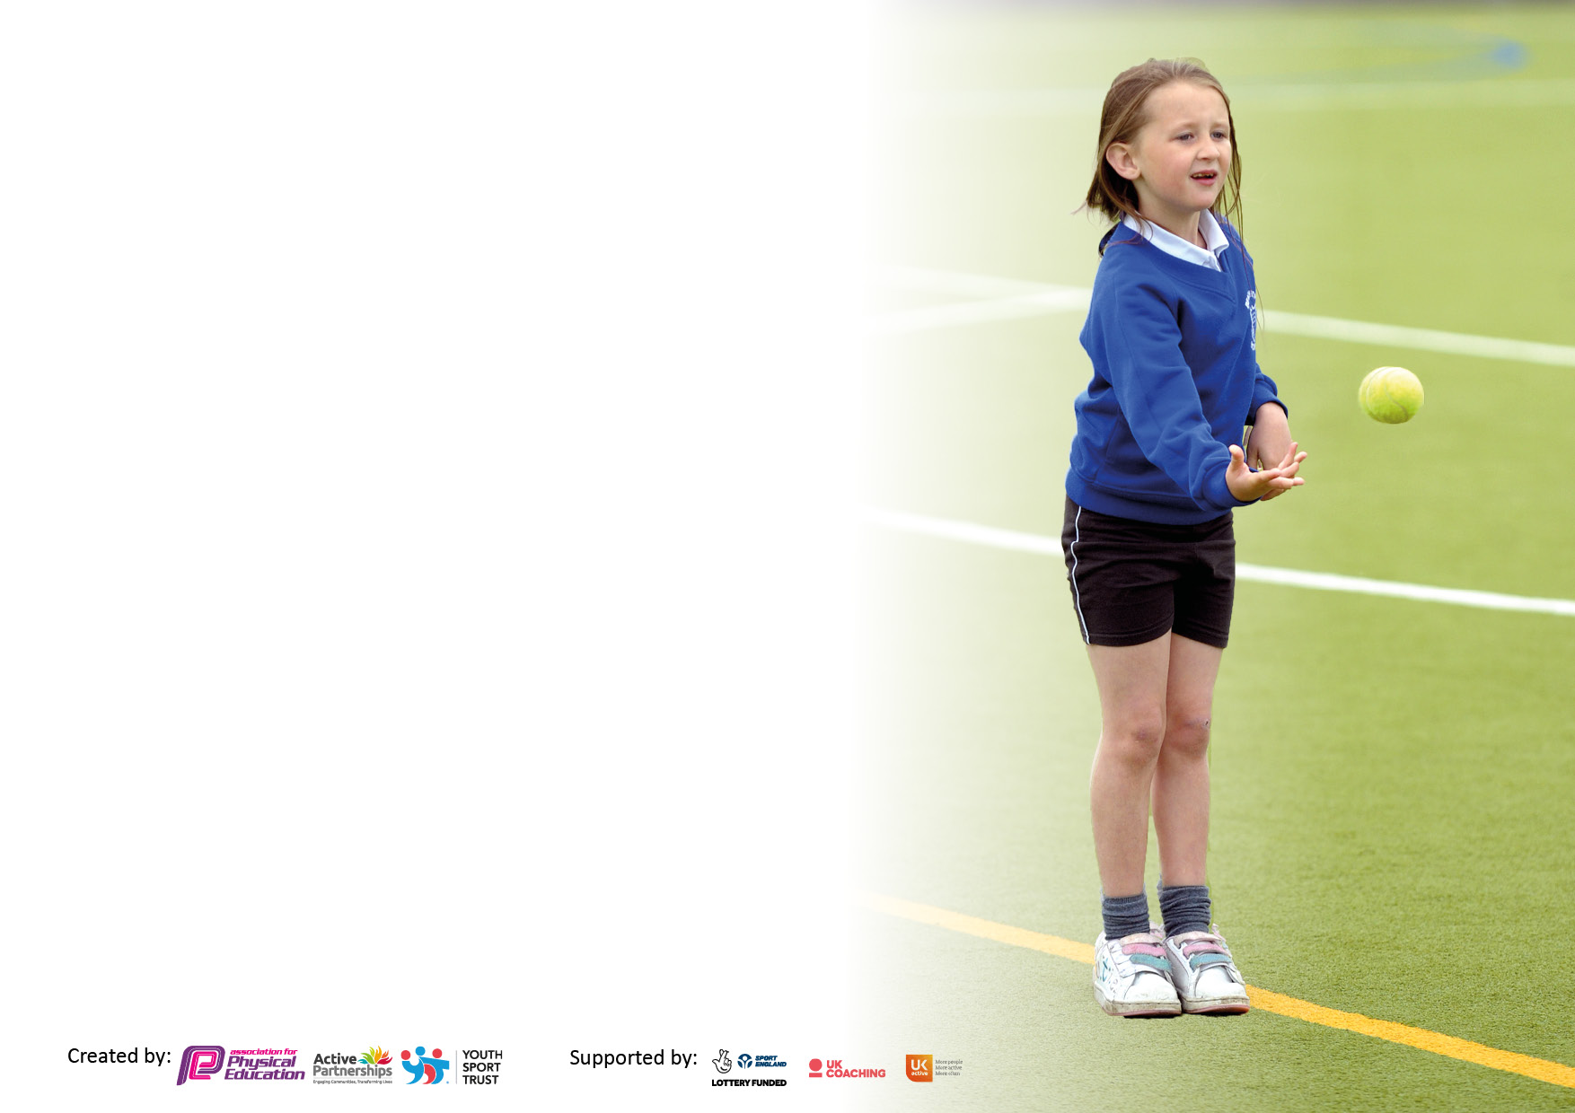

It is important that your grant is used effectively and based on school need. The Education Inspection Framework makes clear there will be a focus on ‘whether leaders and those responsible for governors all understand their respective roles and perform these in a way that enhances the effectiveness of the school’.

Under the Quality of Education Ofsted inspectors consider:
Intent - Curriculum design, coverage and appropriateness
Implementation - Curriculum delivery, Teaching (pedagogy) and Assessment
Impact - Attainment and progress

To assist schools with common transferable language this template has been developed to utilise the same three headings which should make your plans easily transferable between working documents.

Schools must use the funding to make additional and sustainable improvements to the quality of Physical Education, School Sport and Physical Activity (PESSPA) they offer. This means that you should use the Primary PE and sport premium to:

- Develop or add to the PESSPA activities that your school already offer
- Build capacity and capability within the school to ensure that improvements made now will benefit pupils joining the school in future years
- The Primary PE and sport premium should not be used to fund capital spend projects; the school’s budget should fund these.

Pleasevisitgov.ukfortherevisedDfEguidanceincludingthe5keyindicatorsacrosswhichschoolsshoulddemonstrate animprovement.Thisdocumentwillhelpyoutoreviewyourprovisionandtoreportyourspend.DfEencouragesschools to use this template as an effective way of meeting the reporting requirements of the Primary PE and sport premium.

We recommend you start by reflecting on the impact of current provision and reviewing the previous spend.

Schools are required to publish details of how they spend this funding, including any under-spend from 2019/2020, as well as on the impact it has on pupils’ PE and sport participation and attainment. All funding must be spent by 31st July 2022.

We recommend regularly updating the table and publishing it on your website throughout the year. This evidences your ongoing self-evaluation of how you are using the funding to secure maximum, sustainable impact. Final copy must be posted on your website by the end of the academic year and no later than the 31st July 2021. To see an example of how to complete the table please click HERE.
Created by: Supported by:

Details with regard to funding
Please complete the table below.

Total amount carried over from 2019/20 | £0
Total amount allocated for 2020/21 | £17587
How much (if any) do you intend to carry over from this total fund into 2021/22? | £0
Total amount allocated for 2021/22 | £17587
Total amount of funding for 2021/22. To be spent and reported on by 31st July 2022. | £17587
Swimming Data
Please report on your Swimming Data below.

Meeting national curriculum requirements for swimming and water safety.

N.B. Complete this section to your best ability. For example, you might have practised safe self-rescue techniques on dry land which you can then transfer to the pool when school swimming restarts.
Due to exceptional circumstances priority should be given to ensuring that pupils can perform safe self-rescue even if they do not fully meet the first two requirements of the NC programme of study
What percentage of your current Year 6 cohort swim competently, confidently and proficiently over a distance of at least 25 metres?  N.B. Even though your pupils may swim in another year please report on their attainment on leaving primary school at the end of the summer term 2021.  Please see note above | 52%
What percentage of your current Year 6 cohort use a range of strokes effectively [for example, front crawl, backstroke and breaststroke]?  Please see note above | 32%
What percentage of your current Year 6 cohort perform safe self-rescue in different water-based situations? | 32%
Schools can choose to use the Primary PE and sport premium to provide additional provision for swimming but this must be for activity over and above the national curriculum requirements. Have you used it in this way? | Yes/No

Action Plan and Budget Tracking
Capture your intended annual spend against the 5 key indicators. Clarify the success criteria and evidence of impact that you intend to measure to evaluate for pupils today and for the future.

Academic Year: 2020/21 | Total fund allocated: £2518 | Date Updated: July 22
Key indicator 1: The engagement of all pupils in regular physical activity – Chief Medical Officers guidelines recommend that primary school pupils undertake at least 30 minutes of physical activity a day in school |  |  |  | Percentage of total allocation:
 |  |  |  | £2518 15%
Intet | Implementation |  | Impact
All year groups to engage in regular timetabled hours of physical education 2hours per week. | Children to have high quality P.E. sessions twice weekly delivered by teaching staff and coaches.  Extracurricular offer of at least 2 sports clubs after school per week  Sports coach employed to support the delivery of PE  Timetables allow for children to have 2 hours- children will continue to come in on PE days in PE kits to save time getting changed.  Swimming Lessons  Transport | Funding allocated:  LA swimming costs£ 900  Transport for swimming £ 890.22 | - Children have gained the fundamental skills to participate in team and individual sports.  - Positive attitudes to health and well-being  - Enjoyment in PE increases, and more children participate in PE lessons  - Basic skills can now be tracked from EYFS upwards, so teachers know which areas to target.  - Basic skills assessment shows progress from baseline to end of year in EYFS/KS1 and LKS2.  - Children build stamina and gain higher level of fitness through P.E. sessions. | Sustainability and suggested next steps:
To increase the number of children who are active during breaktimes. | P.E. lead to work with school representatives to promote physical activity during breaktimes.  P.E. lead and school representatives to create 2 weekly rota of focused activities.  Kabs activity leaders in place  Sports coach timetables for 2 hours per week to support lunch times. | 2 days x 38 weeks per year at £140 per day.  Total= £10640  £2 hours of sports coach time x 2 per week £56x13 = £728 | - Children have gained the fundamental skills to participate in team and individual sports.  - Children build stamina and gain higher level of fitness through breaktimes. | Activity leader training and CPD
Key indicator 2: The profile of PESSPA being raised across the school as a tool for whole school improvement |  |  |  | Percentage of total allocation:
 |  |  |  | £10419 60%
Intent | Implementation |  | Impact
To provide children with quality resources that allow children to explore and experience both for after school clubs / break/ dinner and PE lessons | Replenish and purchase new equipment allocation.  Hockey pitch fencing | Funding allocated Equipment for sessions: £1230 including storage shed for PE equipment:  Equipment for break times- £1000  Extra for bubbles (Jan – March)  £600  Hockey pitch £7589 | Children have accessed quality resources that allow outcomes to be maximised.  Children to have | Sustainability and suggested next steps:
To raise the profile of P.E. with school and the community. | Using school’s social media accounts to celebrate sports.  Sports day  Football fun day- celebrating women’s Euros  To enhance P.E notice board. | Sports day marking costs £38.00  Sports day equipment cost £ 987  Football fun day equipment £ | Children and families value the importance of P.E. in terms of the benefits including physical gains, emotional well-being as well as understanding cross-curricular outcomes.  P.E. notice board promotes the importance of the subject for children, family and visitors.

Key indicator 3: Increased confidence, knowledge and skills of all staff in teaching PE and sport |  |  |  | Percentage of total allocation:
 |  |  |  | £3135 18%
Intent | Implementation |  | Impact
To provide children with a variety of opportunities to gain high quality teaching from professionals within the field of sport. | Saints Rugby day | rugby day £385  allocated: | Staff have gained confidence via observations and team teach strategies to develop their own practice. All children benefit for higher quality teaching across school. | Sustainability and suggested
 |  |  |  | next steps:
To ensure that all staff gain confidence with delivery of the subject. | P.E. lead to support with CPD for staff.  Lancs PE scheme and support from Sports coach in delivery.  Swimming CPD x 2 teachers  Staff to have access to appropriate planning.  Monitoring of PE lessons by PE lead  Long term planner created with key Skills and progression planned across the mixed year groups. | Swimming CPD £600  £1300 for subscription to Lancs planning  Online assessment tool £360  Supply costs to allow staff to have CPD £585 | Staff have gained confidence via observations and team teach strategies to develop their own practice. All children benefit for higher quality teaching across school.
To provide children with quality first lessons through appropriate and challenging body of work. |  |  | Teachers to have a clear view of progression of skills and knowledge across the sport. Children benefit for quality sessions that have been supported by professionals.
Key indicator 4: Broader experience of a range of sports and activities offered to all pupils |  |  |  | Percentage of total allocation:
 |  |  |  | £1213 7%
Intent | Implementation |  | Impact
Provide opportunities for children to experience a wide range of sporting activities. | Ensure that children are actively taken part in sporting competitions.  P.E. Lead and school members to work alongside sports games organisers to attend events.  Gym equipment servicing | Funding  allocated:  Gym: £485 | Percentage of children have increased taken part in competitive sports. Children have been given the opportunity to work towards a sporting goal. | Sustainability and suggested
 |  |  |  | next steps:
Increase the provision of after school clubs | Extra curricular clubs planned 2 per week/ change each half term to widen variety P.E. lead to work alongside SLT to provide maximum opportunities for children to actively take part in additional sporting activities. | £ Pro rata per 2 hours per week £28 per hour x2=£56 x 13 weeks=  £728 | Percentage of children have increased taken part in competitive sports.  Children are able to build self-esteem and confidence with a wide variety of sports.

Key indicator 5: Increased participation in competitive sport |  |  |  |  |  | Percentage of total allocation:
 |  |  |  |  |  | £1650 9%
Intent |  |  | Implementation |  | Impact
To participate in competitive sports both intra and inter school activities. |  |  | P.E. lead to work alongside school games organiser and SLT to ensure that Carr Mill children are entering events at a competitive level.  Competitions entered | Funding  SHAPES £850  Transport £800 | An increased number of children have represented school for a sporting event.  Carr Mill children gain an understanding of working towards a goal. | Sustainability and suggested
 |  |  |  |  |  | next steps:
Raise the profile of competitive sports by having all year groups hosting an intra school competition. |  |  | Class teachers to provide children with the opportunity to develop intra sporting events.  Football Fun day |  | 100% of children have taken part in an intraschool event.  100% of children have represented themselves/their team in an event.  An increased level of enjoy in a physical activity that promotes mental well-being gains.
Increase the after-school provision of sports on offer. |  |  | P.E. Lead to work with SLT to provide an after school curriculum offer that promotes sporting opportunities.  See above |  | Percentage of Carr Mill children engaging in sessions that develop skills and knowledge of physical education.
 | Signed off by
 | Head Teacher: | AMaley
 | Date: | July 2022
 | Subject Leader: | V Kennedy/ J Newby
 | Date:
 | Governor:

